Day - 7 Session Tracking

- HttpSession

Create a shopping website Big Mart for the users.
User should be able to login by using login.jsp and proper authentication should be done by using database. For successful login “home.jsp” should be shown. Username should be shown at right hand upside corner on each page of website now.
On home page give links for Cosmetics and Electronics section.
If clicked on Cosmetics link, control should go to cosmetic.jsp. Give user at least 5 options of cosmetics, from which he should choose items. After choosing he can go back to home or proceed with payment.

If clicked of Electronic, electronic.jsp should be shown which should offer the user at least 5 electronic devices. User can go to payment or go back to home.
On “payment.jsp” list the selected items from Electronics.jsp and Cosmetic.jsp. Display the final bill to the user.(Data should be carried across the pages by using session tracking mechanism.)
Give an option of log out link on each page after login. If user clicks on Log out, session should be invalidated.

- ShoppingCart Application:
Create cartForm.html page with prodName,qty with 4 buttons like Add,Update,Delete,List buttons.

CartServlet has to receive these 2 values ie., prodName,qty. Store/update/delete/list all product details and store these values in HttpSession based on the corresponding button clicked by the user and display product info.

3)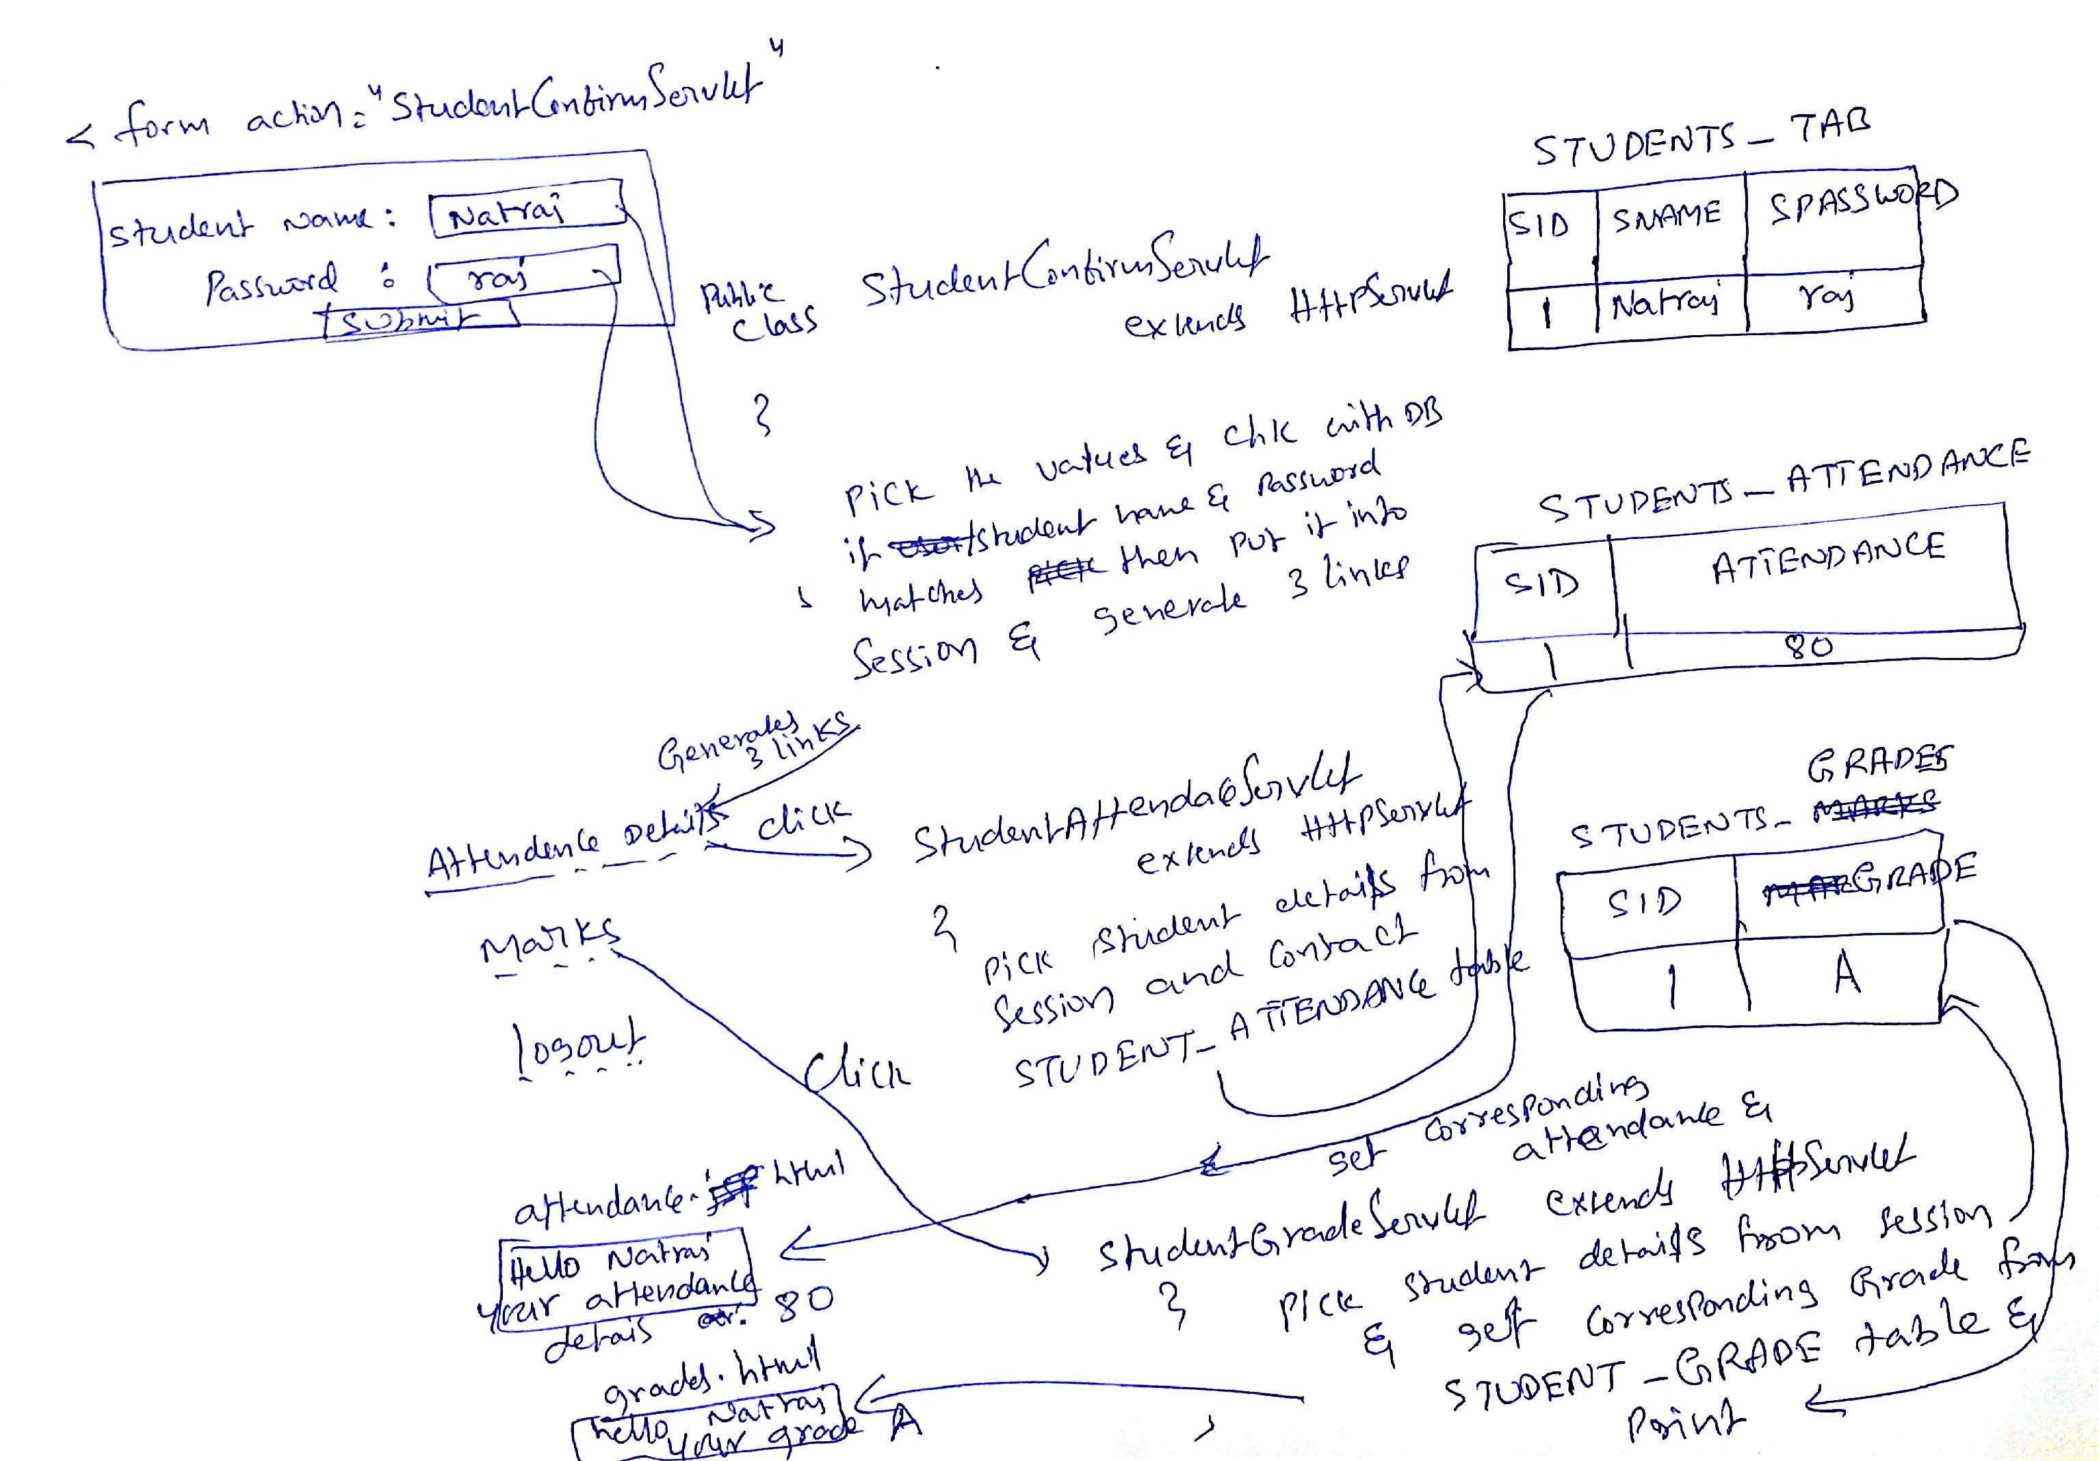

student.html page contains student name, password once student submits StudentConfirmServlet will check whether student is valid student or not(This servlet will contact STUDENTS_TAB), if student is authorized student then put it into HttpSession and generate 3 links

Attendance Details
Marks
Logout

- If Student clicks Attendance Details link then StudentAttendaceServlet will be receive this request and retrieve student details from session and contacts STUDENTS_ATTENDACE table and get the corresponding attendance of the student and forward the control to attendace.html page and prints attendance details along with user name.

- If Student clicks Marks link then StudentGradeServlet will be receive this request and retrieve student details from session and contacts STUDENTS_GRADE table and get the corresponding grade of the student and forward the control to grades.html page and prints grade details along with user name.

3) HTTPSession + Cookie

Create an employee.html form accepting Employee information from user. Form should have Id, name, salary, gender text fields to accept the information. Once submitted the control should go to EmployeeServlet.java.
In the servlet get all the values from HTML page. Store the values in a Java class Employee.java having same variables as of text field names of HTML. Also create getter setter for those variables.
Value should be stored in Employee class by making use of setter methods.

Store that Employee Object on HTTPSession scope.

Create a cookie in EmployeeServlet which will store employee id in a cookie. Once added the cookie on response, transfer the control to next page i.e. ShowServlet.java.
In this servlet, get all the cookies coming from request and display the details of the cookie which you have created in previous servlet.
Also get the stored Employee object from session and display the details of it on the browser.
[Note: use Redirection to transfer the control between servlets]

- URL Rewriting + Hidden Form Fields

Create a Login.java Servlet. Accept username and password from user.

In that form one hidden parameter should be there which will store the session ID into it. This hidden parameter should be transferred along with form data.

Once submitted, the control should go to URLServlet.java
Get all the details of user from HTML along with session Id. Modify the current URL by adding this session ID in the URL and forward the control to DisplayServlet.java. On this page get the id from URL and display on the browser.

